2019 Applied Maths Higher Level Questions

1.
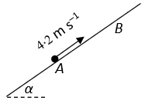
A particle P, of mass 3 kg, is projected along a rough inclined plane from the point A with speed 4∙2 m s^{–1}. The particle comes to instantaneous rest at B.
The plane is inclined at an angle 𝛼 to the horizontal where $\tan{α= \frac{9}{40}}$.
The coefficient of friction between the particle and the plane is $\frac{3}{20}$ .
- Show that the deceleration of P is $\frac{15g}{41}$.
- Find ∣AB∣.
- After reaching B the particle slides back down the plane.
Find the speed of P as it passes through A on its way back down the plane.

(b)
Train A and Train B are on parallel tracks and travelling in opposite directions.
Train A starts from rest at Maynooth and accelerates uniformly at 0∙5 m s^{–2} towards Leixlip to a speed of 25 m s^{–1}. It then continues at this constant speed.

At the same instant as train A is leaving Maynooth Train B passes through Leixlip heading towards Maynooth at a constant speed of 30 m s^{–1}.
Three minutes after leaving Leixlip train B starts to decelerate at 0∙25 m s^{–2} and comes to rest at Maynooth.
- Find the distance between Maynooth and Leixlip.
- At what distance from Maynooth do the trains meet?
- After travelling at 25 m s^{–1} for a time, train A decelerates and comes to rest at Leixlip 36 seconds after train B stops at Maynooth.
Find the deceleration of train A.

2.
(a)
A man walks at a constant speed of 4 km h^{–1} from west to east on level ground.
The wind appears to the man to come from a direction north 50° east.
At the same time a woman walking in the direction north 40° west, and also walking at 4 km h^{–1}, notices that the wind appears to come from the north.
Find the magnitude and direction of the velocity of the wind.

(b)
A rescue boat, whose maximum speed is 24 km h^{–1}, is 18 km south west of a fixed point P. There is a constant current of 4 km h^{–1} flowing uniformly in the direction south 30° east. The rescue boat sets out to get to P as quickly as possible.
- Find the time, to the nearest minute, to reach P.
- A yacht is in distress near P and it sends a signal to the rescue boat. When the rescue boat arrives at P, the yacht is 6 km north of P and is drifting with the current. The rescue boat sets out from P to reach the yacht as quickly as possible.
Find the time taken by the rescue boat to reach the yacht.

3.
(a)
A particle is projected with speed 40 m s^{–1} from a point A on the top of a vertical cliff of height 30 m.
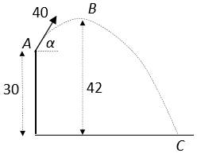
The maximum height reached by the particle is 42 m above the horizontal ground, at point B.
It strikes the ground at C.
Find
- the value of 𝛼, the angle of projection
- the horizontal range of the particle
- the speed of the particle as it hits the ground at C.

(b)
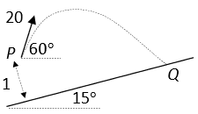
A plane is inclined at an angle 15° to the horizontal. A particle is projected from a point P above the plane with initial speed 20 m s^{–1} at an angle of 60° above the horizontal.
The point P is at a perpendicular distance of 1 m from the inclined plane.
The plane of projection is vertical and contains the line of greatest slope.
The particle strikes the plane at a point Q.
Find
- the time taken for the particle to travel from P to Q
- the speed of the particle at the point where it is travelling parallel to the inclined plane.

4.
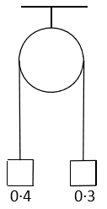
(a)
Two particles of masses 0∙4 kg and 0∙3 kg are attached to the ends of a light inextensible string which passes over a light smooth fixed pulley.
They are held at the same level, as shown in the diagram.
The system is released from rest.
Find
- the tension in the string
- the speed of the 0∙4 kg mass when it has descended 0∙7 m.

(b)
A smooth wedge of mass 3m rests on a smooth horizontal surface.
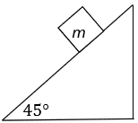
One face of the wedge makes an angle of 45° with the horizontal.
A particle of mass m is placed on the smooth inclined face of the wedge. The system is released from rest.
- Show, on separate diagrams, the forces acting on the wedge and on the particle.
- The particle moves with acceleration 𝑝 relative to the wedge and the wedge moves with acceleration 𝑞.
- Find the value of p and the value of q.

5.
(a)
A small smooth sphere A, of mass 3m moving with speed u, collides directly with a small smooth sphere B, of mass m moving with speed u in the opposite direction.
The coefficient of restitution between the spheres is $\frac{1}{2}$.
- Find, in terms of u, the speed of each sphere after the collision.

- After the collision B hits a smooth vertical wall which is perpendicular to the direction of motion of B. The coefficient of restitution between B and the wall is $\frac{2}{5}$.
The first collision between the s pheres occurred at a distance 2 metres from the wall. The spheres collide again 4 seconds after the first collision between them.
Find the value of u.

(b)
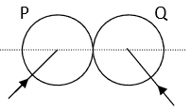
A smooth sphere P, of mass 2m, collides with a smooth sphere Q, of mass m.
The velocity of P is 3𝑢 𝚤⃗+4𝑢 𝚥 ⃗ and the velocity of Q is −4𝑢 𝚤⃗+3𝑢 𝚥 ⃗, where 𝚤 ⃗ is along the line of centres at impact.
The coefficient of restitution between the spheres is $\frac{5}{7}$.
Find
- in terms of 𝑢, the speed of each sphere after the collision
- the angle between the directions of P and Q after the collision.

6.
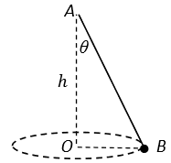
(a)
One end A of a light elastic string is attached to a fixed point.
The other end, B, of the string is attached to a particle of mass m.
The particle moves on a smooth horizontal table in a circle with centre O, where O is vertically below A and |AO|=ℎ.
The string makes an angle 𝜃 with the downward vertical and B moves with constant angular speed 𝜔 about OA.
- Show that 𝜔² ≤ $\frac{g}{h}$.
- The elastic string has natural length ℎ and elastic constant $\frac{2mg}{h}$.
Given that 𝜔² = $\frac{2g}{5h}$ , find the value of 𝜃.

(b)
A particle P of mass 0∙5 kg is suspended from a fixed point Q by a light elastic string of natural length 0∙65 m and elastic constant 24·5 N m⁻¹.
The particle hangs in equilibrium at the point R, vertically below Q.
- Show that |QR|=0∙85 m.

The particle is now pulled down 0∙3 m from the equilibrium position and released from rest.
- Show that while the string is taut, P is moving with simple harmonic motion.
- Calculate the maximum speed of P.

7.
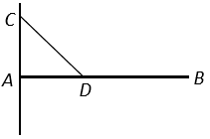
(a)
A uniform rod AB of length 1∙5 m and mass 3 kg is smoothly hinged to a vertical wall at A.
The rod is held in a horizontal position by a string attached to the rod at D and to a point C vertically above A on the wall. |AC|=|AD|=0∙5 m.
Find the magnitude and direction of the force exerted on the rod at A.

(b)
Two equal uniform rods GF and FE, each of length 2𝑙 and weight W, are smoothly jointed at F.
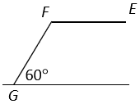
The rods are in equilibrium with the end G resting on a rough horizontal surface.
The end E is held above the surface.

The rod FE is horizontal, and the rod GF is inclined at an angle of 60° to the horizontal.
G is on the point of slipping.

Find
- the coefficient of friction
- in terms of W, the horizontal and vertical forces at E.

8. (a)
Prove that the moment of inertia of a uniform rod, of mass m and length 2𝑙 about an axis through its centre, perpendicular to the rod, is $\frac{1}{3}$𝑚𝑙².

(b)
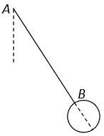
A uniform rod AB of mass m and length 1 m has a uniform disc of mass m and radius 10 cm attached at B. The rod and disc are in the same plane and the rod is colinear with a diameter of the disc as shown in the diagram.

The compound body oscillates about a fixed smooth horizontal axis which passes through A and is perpendicular to the plane of the rod and disc.

Find
- the moment of inertia of the compound body about the axis of rotation
- the period of small oscillations correct to two decimal places
- the length of the equivalent simple pendulum.

9.
(a)
When 2 specific substances are mixed, the volume of the mixture is equal to the sum of the original volumes.
When equal volumes of these two substances are mixed, the relative density of the mixture is 0∙8.
When equal masses of the same two substances are mixed the relative density of the mixture is 0∙6.
Find the relative densities of the two substances.

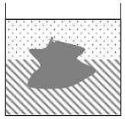
(b)
A liquid of density 𝜌 rests on another liquid of density 2𝜌 without mixing.
A solid of density 𝑑 floats with its surface totally covered by liquid and with part of its volume immersed in the upper liquid.
Show that the fraction of the volume of the solid immersed in the upper liquid is $\frac{2ρ-d}{ρ}$ .

10.
(a)
A particle P moves along a straight line.
The speed of P at time 𝑡 is 𝑣, where 𝑣=𝑎𝑡² +𝑏𝑡+𝑐 and 𝑎,𝑏 and 𝑐 are constants.
The initial speed of the particle is 15 m s⁻¹.
After 2∙5 seconds the particle reaches its minimum speed of 2∙5 m s⁻¹.
Find
- the value of 𝑎, the value of 𝑏, and the value of 𝑐
- the acceleration of P when 𝑡 = 4 seconds
- the distance travelled by P in the third second of the motion.

(b)
A particle, of mass 𝑚 falls vertically downwards under gravity.
At time 𝑡, the particle has speed 𝑣 and it experiences a resistance force of magnitude 𝑘𝑚𝑣, where 𝑘 is a constant.
The initial speed of the particle is 𝑢.
- Show that 𝑣 = $\frac{g}{k}-(\frac{g}{k}-u)e^{-kt}$, at time 𝑡.
- If 𝑢=9∙8 m s⁻¹ and 𝑘=0∙98 s⁻¹, find the distance travelled by the particle in 4 seconds.

(Note: $\int{\frac{dx}{a+bx}}$ = $\frac{1}{b}$ln|𝑎+𝑏𝑥 |+𝑐).

